C# Introduction – Console and Windows Applications

Exercise 1
Open Visual Studio and create a new C# Project (File, new project) using the Console Application template. Call it “Numbers”.

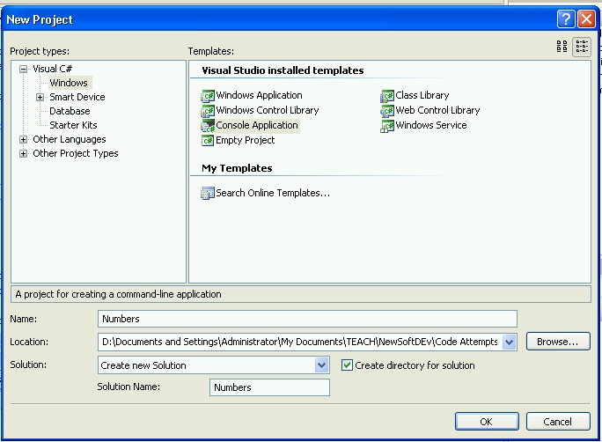

Amend your code as shown below

static void Main(string[] args)
{
int num1, num2;
string input;
Console.WriteLine("Enter 1st Number :");
input = Console.ReadLine(); //waits for user to hit return
num1 = Convert.ToInt32(input);
Console.WriteLine("Enter 2nd Number :");
input = Console.ReadLine();
num2 = Convert.ToInt32(input);
Console.WriteLine("Sum is : {0}", sum(num1, num2));
//{0} takes 1st argument and substitutes into string
Console.ReadKey(); //waits for a key to press before ending
}

static int sum(int x, int y)
{
return x + y;

}

Run your program by clicking the button on the toolbar.

Part A) Now alter the program to calculate the power of num1 to num2 using a for loop within a suitable static function.
Part B) Alter the program above to allow the input of n numbers and calculate the average. [hint : use a while loop with a running total and a count variable.]

Exercise 2
Create a new C# Project using the Windows Forms Application template. Call it “SimpleApp1”.
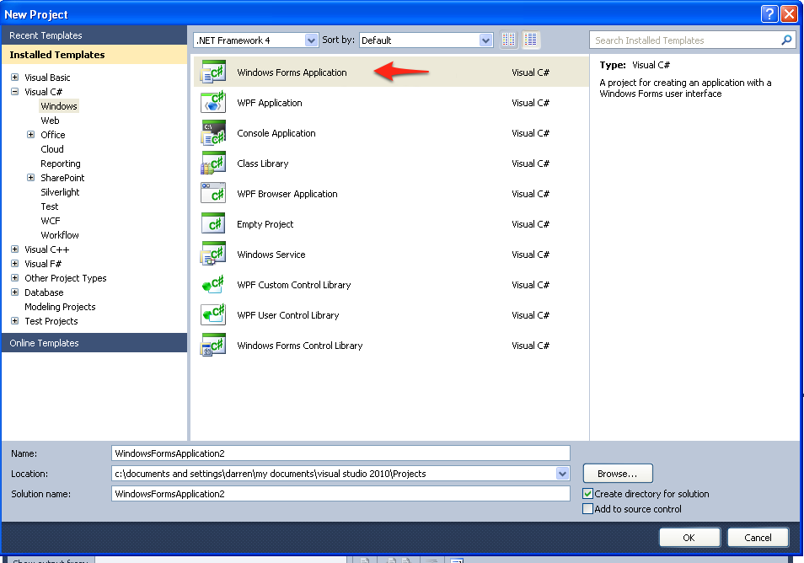
Create the following GUI interface in C# by dragging a Button, a label and a textbox from the ToolBox to the form.
Run your program by clicking the button on the toolbar.
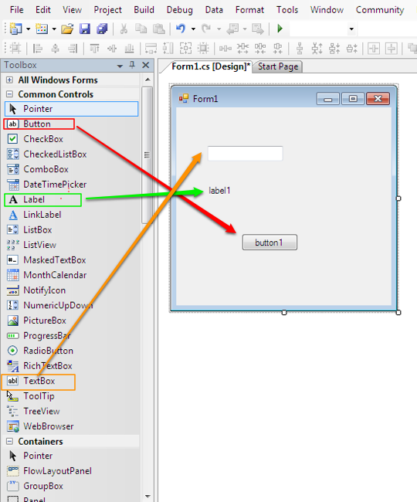
We now need to add some code to the program to make it do something a bit more interesting.
Double click the button (in design mode) and add the following code (in bold) to the button click handler, the rest of the code will be already there.
using System;
using System.Collections.Generic;
using System.ComponentModel;
using System.Data;
using System.Drawing;
using System.Text;
using System.Windows.Forms;

namespace SimpleApp1
{
public partial class Form1 : Form
{
public Form1()
{
InitializeComponent();
}

private void button1_Click(object sender, EventArgs e)
{
label1.Text = textBox1.Text;
}
}
}

Run the program again. This time the text entered into the textbox should be copied to the label when the button is pressed.

Exercise 3
Create a program (call it “Lab1_GUI”) with a similar interface to the one below. Using the properties inspector name your controls with sensible names such as those suggested below
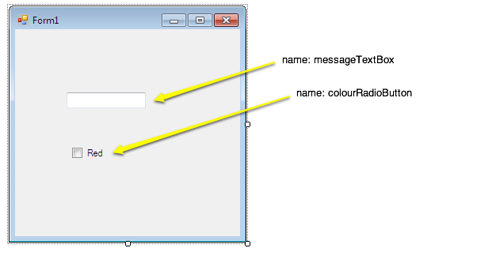
name: ColourCheckBox

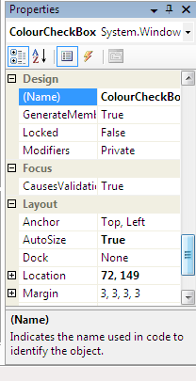
By Double-clicking on the CheckBox an eventhandler will be created for the CheckedChanged event of the checkbox. The textbox has a properties called ForeColor which determines the colour of the text displayed. Change the event handler such that when it is clicked the text changes to Red.
private void checkBox1_CheckedChanged(object sender, EventArgs e)
{
messageTextBox.ForeColor = Color.Red;

}

Exercise 4 [Portfolio]
The last program has a bug because although the colour changes to red when the checkbox is first checked it then remains red even after the checkbox has been cleared.
The Checkbox has a property called Checked that is true if the checkbox is checked and false if not.
ColourCheckBox.Checked == True
Using an IF statement in the CheckChanged event handler make the text change between red and black depending on the state of the ColourCheckBox.

Exercise 5
Create a simple calculator program with an interface similar to the one below.
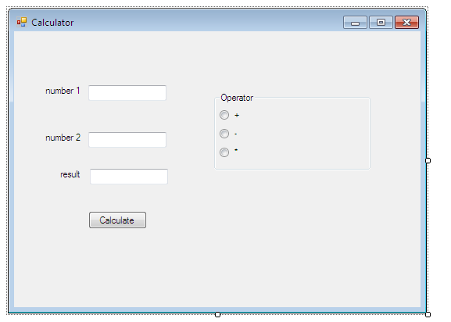
The program only needs code adding to the calculate button click event. You will need to convert the strings in the textboxes to numbers using something like
int num1 = Convert.ToInt32(textBox1.Text);

To check whether a radio button is checked examine its checked property.
Add a power radio button and use a for loop to calculate the result of number1 to the power of number 2.

Exercise 6
Produce a second version of your calculator where the entire mathematical expression is entered in a single text box. We’ll assume this expression consists of two integer numbers separated by a single operator with a space between each e.g. “2 + 5”.
Your GUI should have a single button which calculates and displays the result when pressed (either as a label, or replacing the string in the text box).
Hint – search for “C# split string” using google or similar

Exercise 7 (useful for interviews)
FizzBuzz Test, commonly used at interview for placements
"Write a program that prints the numbers from 1 to 100. But for multiples of three print “Fizz” instead of the number and for the multiples of five print “Buzz”.
For numbers which are multiples of both three and five print “FizzBuzz”."

